Data Application – The Celebrity Avengers Planning

By Tom Tran

11/3/2021

NEWM-N 320: Intermediate to Media Application Development

Intro:

**“'Cause baby, now we've got bad blood. You know it used to be mad love. So, take a look what you've done. Cause baby, now we've got bad blood.”** – Taylor Swift; 1989

Everyone loves the obsession or temptation of retaliating your own worst nemesis. Therefore, it’s addicting and “juicy”, and it can create the major accusations between the opponents, basically the “he said, she said." For example, in my own perspective, my ex-best friend accused me of lying that I wanted to hang out with the family instead of going hiking with her and her boyfriend from last Summer. Toxicities is at its finest and it’s the opposite of “tough love.”

My decision is to create trading cards that is inspired of my current beef with that bitch Andrea Capunay, utilizing HTML, CSS, JavaScript, and other JavaScript programming languages that I learned throughout in class this semester. It’s called “The Avenger”, but with celebrities. Just to note there: this is fictional and if those celebrities are feeling offended, I apologized for the misunderstanding but again, this is fictional. Please don’t “@” me or DM me for negative tendencies, verbally. Don’t try to sue me when you see my project. This is for my class final project.

Female Avengers:

**Bella Hadid**

**Alias: Unmerciful Revenger**

Sharped and skilled, this hot model Bella shows no mercy. After one of her models Hailey Bieber ultimately betrayed her in the middle of the New York Fashion Show, she is left isolated and hopeless. Now working for “The Avengers,” she is capable of exhibiting her brawns and brains by showing her unmerciful revenge side to get back to her modeling career.

**Britney Spears**

**Alias: Toxic Slasher**

Since 2007-2008, Britney Spears had been in ups-and-downs lately, from her head-shaving to dealing with bullshits such as Christina Aguilera cheating with her past men. Now in conservatorship for 13 years, she’s sick in tired of her father financially abused her and prevents her from performing and conducting her own decisions. As a leader of “The Avengers,” she is willingly taking revenge on her father so she can get her life back and get back to her love life with Sam Asghari after he cheated on her with Christina.

**Camila Cabello**

**Alias: Viuda Negra**

Born in Miami, Camila is no stranger to the sex community when the men are asking her for sexual wooing. Camila isn’t afraid to show some “poison love” to men that they favored for and even have sex with men in BDSM-style. In the end, she then poisoned her men with black widow substance and wrapped them with venomous cobwebs. Now to get revenge on her ex-boyfriend, she’ll be able to confront him, venomously and get him to justice.

**Camila Mendes**

**Alias: Unremorseful Milkshake**

Bio added…

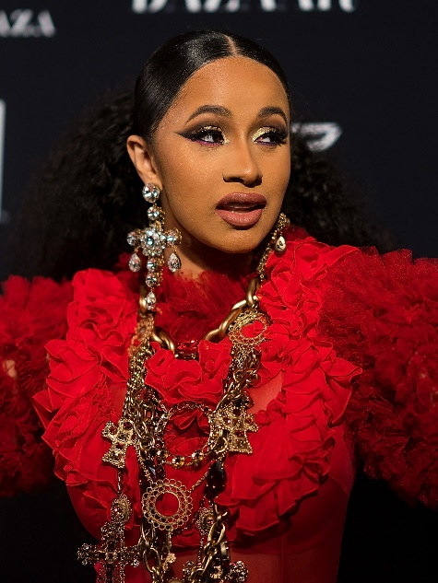**Cardi B**

**Alias: The Boss Bitch**

Bio added…

**Emma Roberts**

**Alias: The Scream Queen**

Bio added…

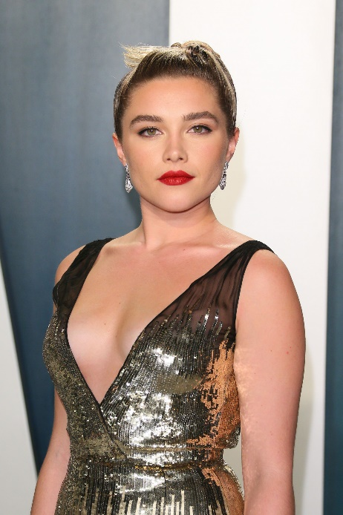**Florence Pugh**

**Alias: Flame Thrower**

Revenge is best served cold… as for Florence! When her relationship with her ex-boyfriend went floundered few days after her family were filled with carbon monoxide, she had enough with his little game and sought revenge to end her relationship: burn his apartment down. Now single and tattooed, this “Midsommar” legendary turned Avenger is spraying up in flames when it comes to confronting adversaries… and to her former exes.

**Gigi Hadid**

**Alias: Slay-Z**

Gigi Hadid as Slay-Z is back and she’s deadlier than ever, thanks to her military background. Looking back to her past, she has a habit of saving femininities including women and children, including her daughter whom she was almost taken away by her ex-fiancé Zayn Malik. After her toxic breakup with him, Zayn then kidnapped her daughter, leaving her distraught and paralyzed her mother, Yolanda. Seeking avenged for her “avengers,” she is reclaiming her title and bringing her daughter back!

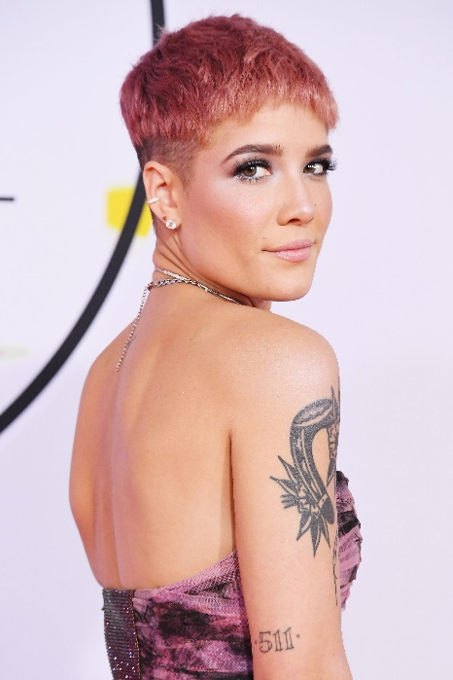**Halsey**

**Alias: Punching Bag**

Ever since she’s a teenager, she was emotionally traumatized, from her being kicked out by her parents for not getting an education to being endured with homeless stoners and ended up getting raped. With her anger and violent tendencies, she is ready to face her traumatic demons and to overcome her undoing what was left behind from her past and move on with her new life.



**Katy Perry**

**Alias: Sour Lollipop**

She can be sweet, but she can be sour. This “candy” vixen can stick you up and leave your life a mess! With her sticky situation, thanks to one of her albums “Teenage Dream,” when there’s a

**Lady Gaga**

**Alias: The Fame Monster**

**Lili Reinhart**

**Alias: Eye-Slashes**